**Operating System.** A program that acts as an intermediary between a user of a computer and the computer hardware

Operating system goals:

* Execute user programs and make solving user problems easier
* Make the computer system convenient to use
* Use the computer hardware in an efficient manner

Four components:

* **Hardware.** CPU, memory, I/O devices
* **Operating system.** Controls and coordinates use of hardware among various applications and users
* **Application programs.** Word processors, compilers, web browsers, database systems, video games
* **Users.** People, Machines, other Computers

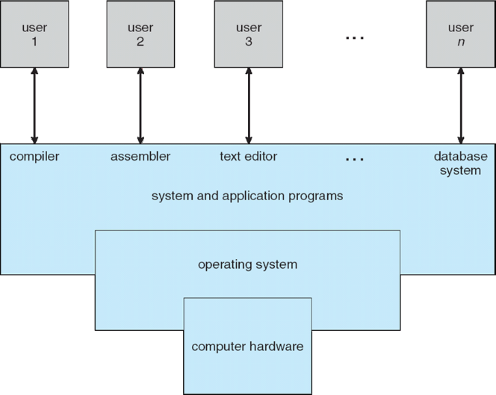

**What Operating Systems Do**

* **Users** want convenience, ***ease******of******use*** *and* ***good performance*.** Don’t care about resource utilization.
* **Mainframe or Minicomputer** must keep all users happy
* **Workstations** have dedicated resources
* **Servers.** shared resources
* **Handheld computers** are resource poor, optimized for usability and battery life
* **Embedded Computers** in devices and automobiles. have little or no user interface

**Operating System Definition**

* **OS is a resource allocator**
* **OS is a control program.** Controls execution of programs to prevent errors and improper use of the computer
* **Kernel.** The one program running at all times
* **System Program**. (ships with the OS)
* **Application Program**

**Computer Startup:**

* **Bootstrap Program** is loaded at power-up or reboot
  + Typically stored in ROM or EPROM, generally known as **firmware**
  + Loads operating system kernel and starts execution

**Computer System Organization**

* Computer-system operation

One or more CPUs, device controllers connect through common bus providing access to shared memory

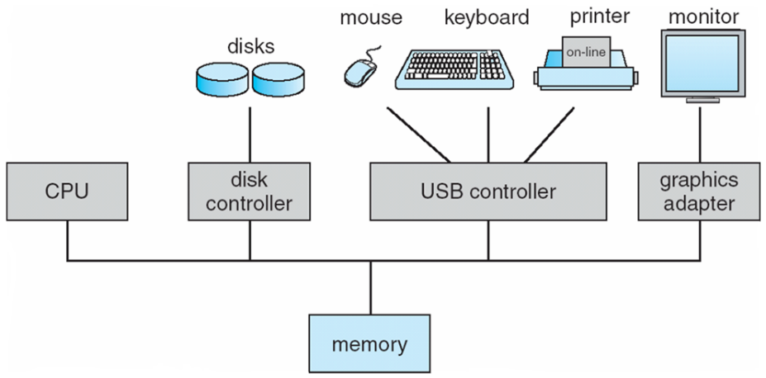

**Difference of Computer Architecture and Computer Organization?**

* **Architecture.** how a computer component works
* **Organization.** how these components are connected, then we are talking about organization

**Computer-System Operation**

* I/O devices and the CPU can execute concurrently
* Each device controller is in charge of a particular device type
* Each device controller has a local **buffer. Data buffer,** is an area of physical memory storage used to temporarily store data while it is being moved from one place to another.
* CPU moves data from/to main memory to/from local buffers
* I/O is from the device to local buffer of controller
* Device controller informs CPU that it has finished its operation by causing an **interrupt**

**Common Functions of Interrupts**

* **Interrupt****Vector.** List of interrupt handlers
* **Trap** or **Exception.** software-generated interrupt caused either by an error or a user request
* An operating system is **interrupt driven**

**Interrupt Handling**

* polling
* vectored interrupt system

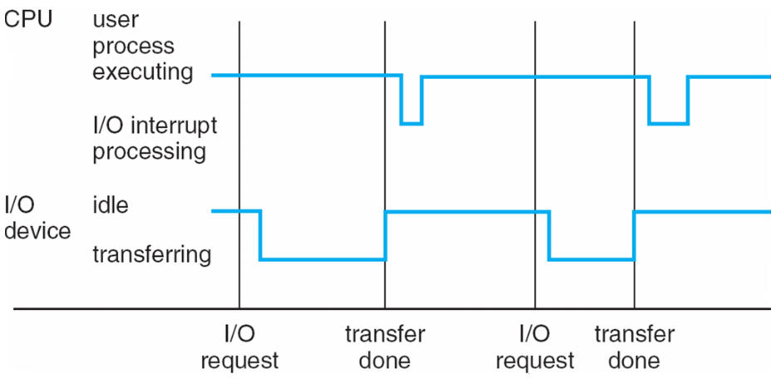**Interrupt Timeline:**

A computer processor is described as **idle** when it is not being used by any program.

**I/O Structure**

* **System call** – request to the OS to allow user to wait for I/O completion
* **Device-status table** contains entry for each I/O device indicating its type, address, and state
* OS indexes into I/O device table to determine device status and to modify table entry to include interrupt

**Storage Definitions and Notation Review**

REVIEW NOTEBOOK AND QUIZES

**Storage Structure**

* **Main memory**
  + Random access
  + Volatile
* **Secondary storage.** Nonvolatile storage capacity
  + MROM (masked read-only memory)
  + PROM (programmable read only memory)
  + EPROM (erasable programmable read only memory)
  + EEPROM (electrically erasable programmable read only memory)
  + Flash Memory
* **Hard disks.** Rigid metal or glass platters covered with magnetic recording material
  + logically divided into **tracks,** which are subdivided into **sectors**
  + **disk controller** determines the logical interaction between the device and the computer
* **Solid-state disks.** faster than hard disks, nonvolatile

**Storage Hierarchy**

Speed

Cost

Volatility

* **Caching** – copying information into faster storage system; main memory can be viewed as a cache for secondary storage
* **Device Driver** for each device controller to manage I/O

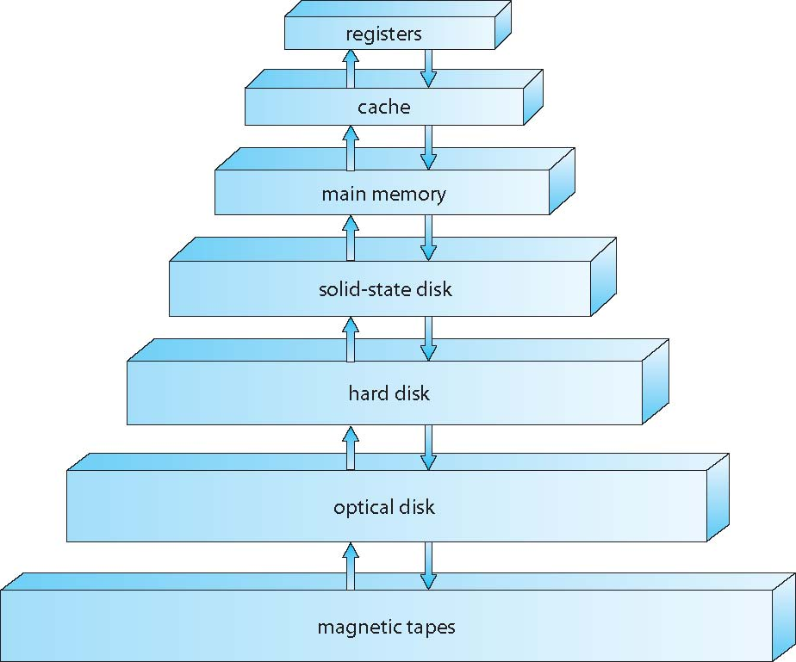

**Direct Memory Access Structure (DMA)**

* 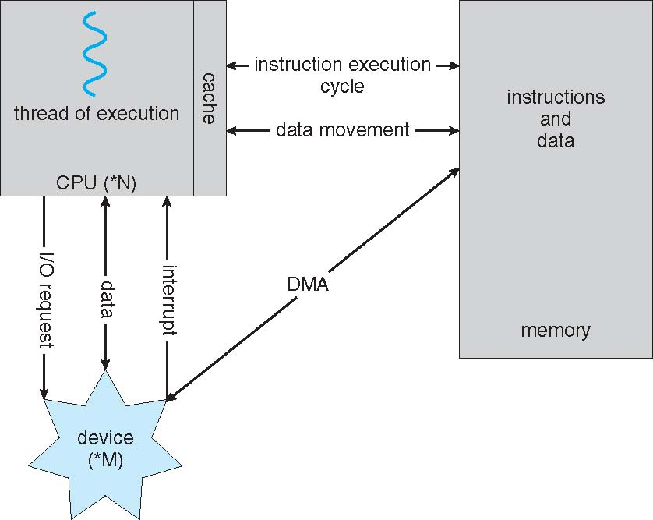Used for high-speed I/O devices able to transmit information at close to memory speeds

Computer-System Architecture

* Single general-purpose processor
* **Multiprocessors**
  + Also known as **parallel systems**, **tightly-coupled systems**
  + Advantages include:
    - **Increased throughput**
    - **Economy of scale**
    - **Increased reliability** – graceful degradation or fault tolerance
  + Two types:
    - **Asymmetric Multiprocessing** – each processor is assigned a specific task.
    - **Symmetric Multiprocessing** – each processor performs all tasks

Read OS-reviewer-quiz-2 and Quiz 2 review

* **SSD.** solid-state drive
* **DMA.** Direct memory access
* **CMOS.** Complementary Metal-Oxide Semiconductor
* **BIOS.** basic input/output system
* **INT.**
* **OS.** Operating System
* **ROM.** Read-Only Memory
* **RAM.** Random Access Memory
* **POST.** Power On Self Test
* **BSOD.** Blue Screen on Display